**Exercise 2: Error Handling**

**Scenario 1: Handle exceptions during fund transfers between accounts.**

**PL/SQL Code:**

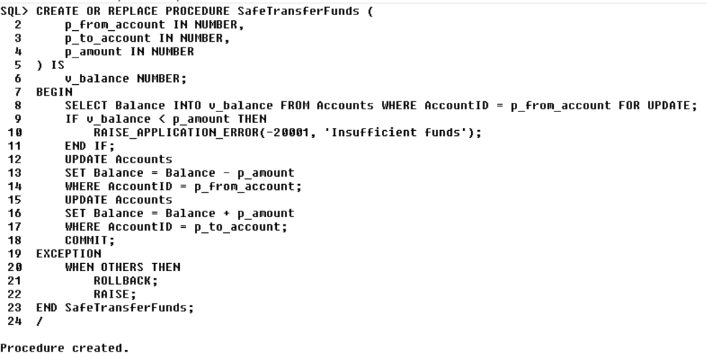

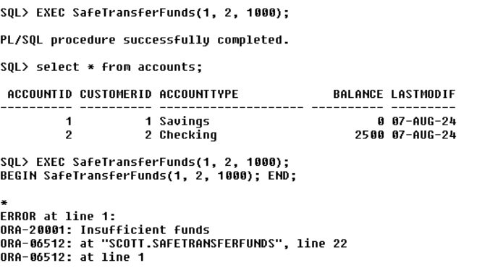

**Scenario 2: Manage errors when updating employee salaries.**

**PL/SQL Code:**

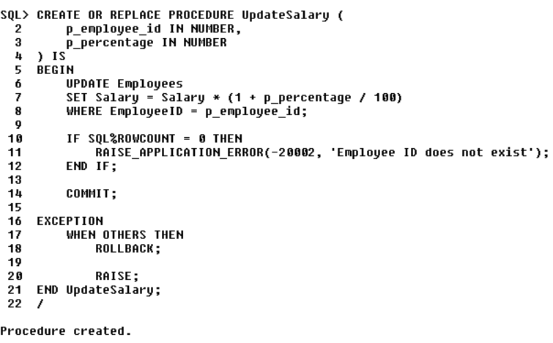

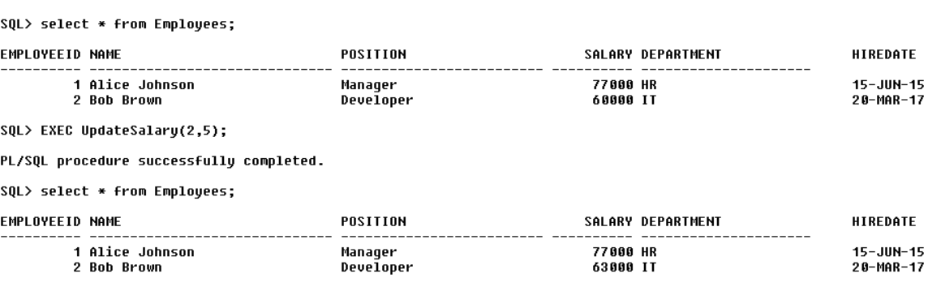

**Scenario 3:** **Ensure data integrity when adding a new customer.**

**PL/SQL Code:**

